**11st week Homework**

* **Create a user-define class Point that contains the private integer data member xCoordinate and yCoordinate and declares steam insertion and stream extraction overloaded operator function as friends of the class**
* **Define the stream insertion and stream extraction operator functions. The stream extraction operator function should determine whether the data entered is valid, and, if not, it should set the failbit to indicate improper input. *The stream insertion operator should not be able to display the point after and input error occurred(%%%%)***
* **Write a main function that tests input and output of user-defined class Point, using the overloaded stream extraction and stream insertion operators.**

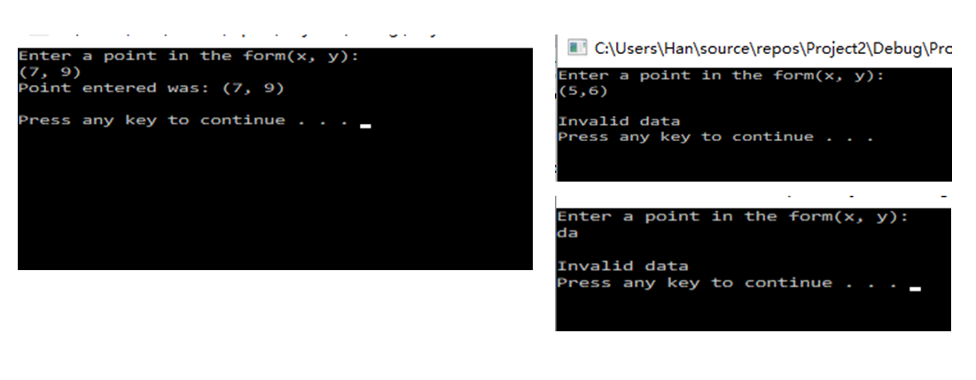

* **in.clear(ios::failbit)**
* **in.ignore()**
* **in.peek()**

